TOPIC 2:BRUTE FORCE ALGORITHM
11.List Examples
Aim: Demonstrate different types of lists.
Python code:
lst = eval(input("Enter a list: ")) if lst == []:
print("Output:", lst) else:
print("Output:", sorted(lst))
Input:
[]
Output:
[]
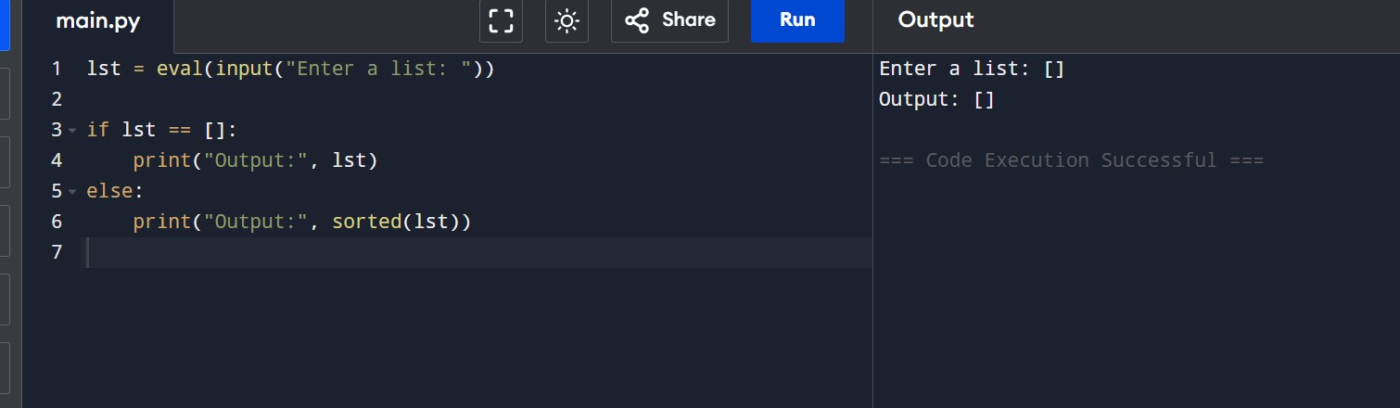

Time Complexity: O(n log n)
Space Complexity: O(n)
Result: Thus, different types of lists were created and displayed successfully.

12.Selection Sort
Aim: Sort an array using Selection Sort.
Python Code:
def selection_sort(arr): for i in range(len(arr)):
min_idx = i for j in range(i+1, len(arr)): if arr[j] < arr[min_idx]:
min_idx = j arr[i], arr[min_idx] = arr[min_idx], arr[i] return arr

arr = eval(input("Enter list to sort: ")) print("Sorted list:", selection_sort(arr))
Input:
[5, 2, 9, 1, 5, 6]
Output:
[1, 2, 5, 5, 6, 9]

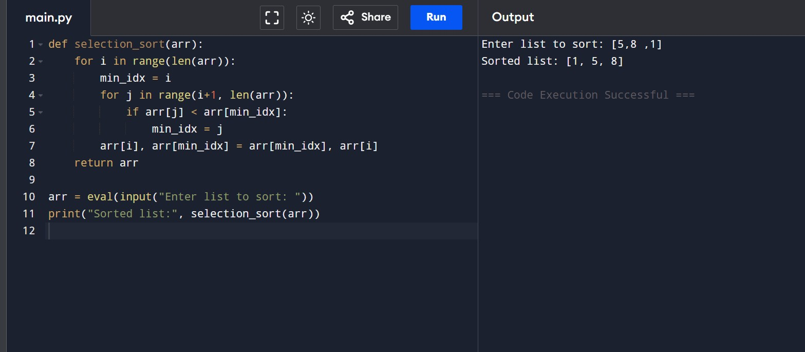
Time Complexity: O(n²)
Space Complexity: O(1)
Result: Thus, the given array was sorted successfully using Selection Sort.
13. Optimized Bubble Sort
Aim: Stop Bubble Sort early if the list is already sorted.
Python Code:
def bubble_sort(arr): n = len(arr) for i in range(n): swapped = False for j in range(0, n-i-1): if arr[j] > arr[j+1]: arr[j], arr[j+1] = arr[j+1], arr[j] swapped = True if not swapped:
break return arr

arr = eval(input("Enter list to sort: "))
print("Sorted list:", bubble_sort(arr))
Input:
[64, 25, 12, 22, 11]
[29, 10, 14, 37, 13]
[3, 5, 2, 1, 4]
[1, 2, 3, 4, 5]
[5, 4, 3, 2, 1]
Output:
[11, 12, 22, 25, 64]
[10, 13, 14, 29, 37]
[1, 2, 3, 4, 5]
[1, 2, 3, 4, 5]
[1, 2, 3, 4, 5]
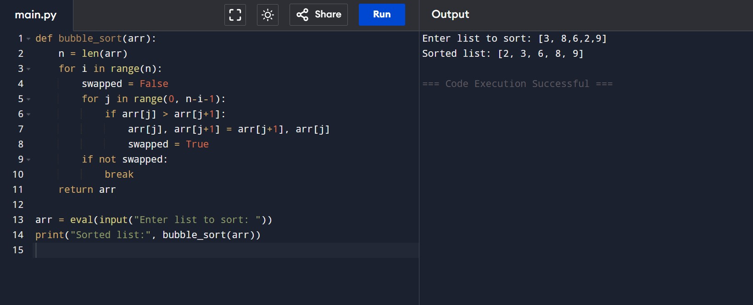

Time Complexity: Best: O(n), Worst: O(n²)
Space Complexity: O(1)
Result: Thus, the array containing duplicate elements was sorted successfully using Insertion Sort.

14. Insertion Sort with Duplicates Aim: Sort arrays including duplicates.
Python Code:
def insertion_sort(arr):
for i in range(1, len(arr)):
key = arr[i] j = i - 1 while j >= 0 and arr[j] > key:
arr[j + 1] = arr[j] j -= 1
arr[j + 1] = key return arr

arr = eval(input("Enter list to sort: ")) print("Sorted list:", insertion_sort(arr))
Input:
[3, 1, 4, 1, 5, 9, 2, 6, 5, 3]
[5, 5, 5, 5, 5] [2, 3, 1, 3, 2, 1, 1, 3]
Output:
[1, 1, 2, 3, 3, 4, 5, 5, 6, 9]
[5, 5, 5, 5, 5]
[1, 1, 1, 2, 2, 3, 3, 3]

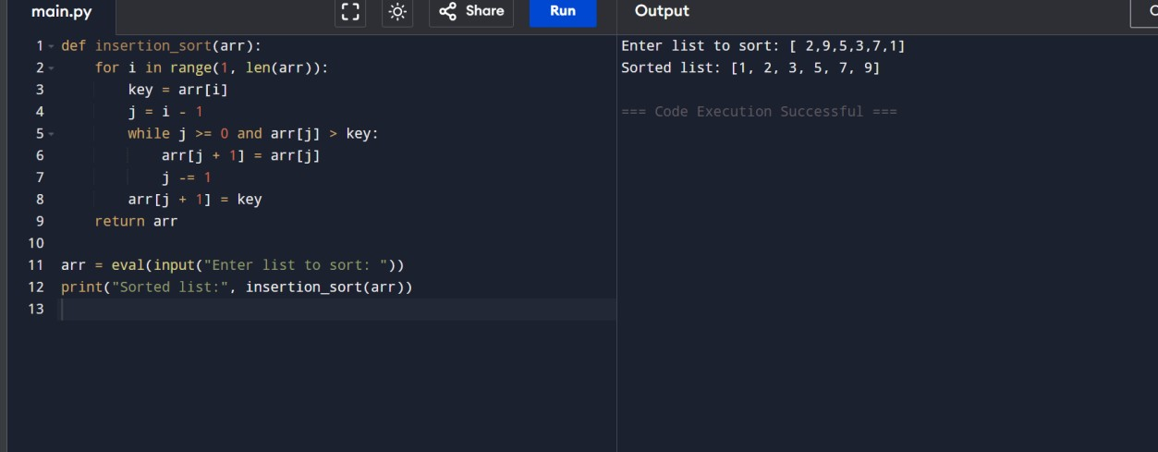

Time Complexity: Best: O(n), Worst: O(n²)
Space Complexity: O(1)
Result: Thus, the array containing duplicate elements was sorted successfully using Insertion Sort.

15. Kth Missing Positive
Aim: Find the kth missing positive number.
Python Code:
def findKthPositive(arr, k):
missing = [] current = 1 while len(missing) < k: if current not in arr:
missing.append(current) current += 1 return missing[-1]

arr = eval(input("Enter sorted list: ")) k = int(input("Enter k: ")) print("Kth Missing Positive Number:", findKthPositive(arr, k))
Input:
[2,3,4,7,11], k=5
[1,2,3,4], k=2
Output:
9
6
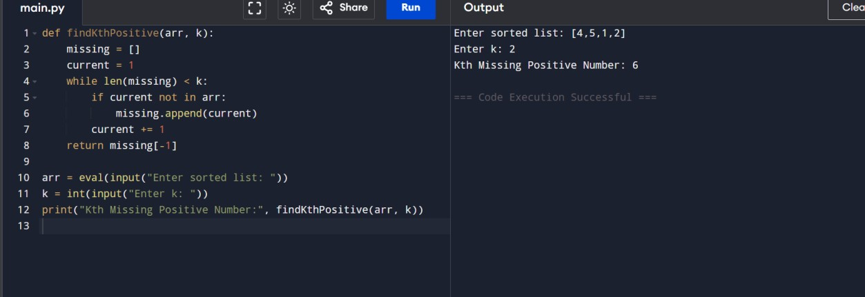
Time Complexity: O(n + k)
Space Complexity: O(k)
Result: Thus, the kth missing positive number was found successfully.

16. Peak Element (O(log n))
Aim: Find a peak element using binary search.
Python Code:
def findPeakElement(nums):
left, right = 0, len(nums) - 1 while left < right:
mid = (left + right) // 2 if nums[mid] > nums[mid + 1]:
right = mid else:
left = mid + 1 return left

nums = eval(input("Enter list: ")) print("Peak element index:", findPeakElement(nums))
Input:
[1,2,3,1]
[1,2,1,3,5,6,4]
Output:
2
5
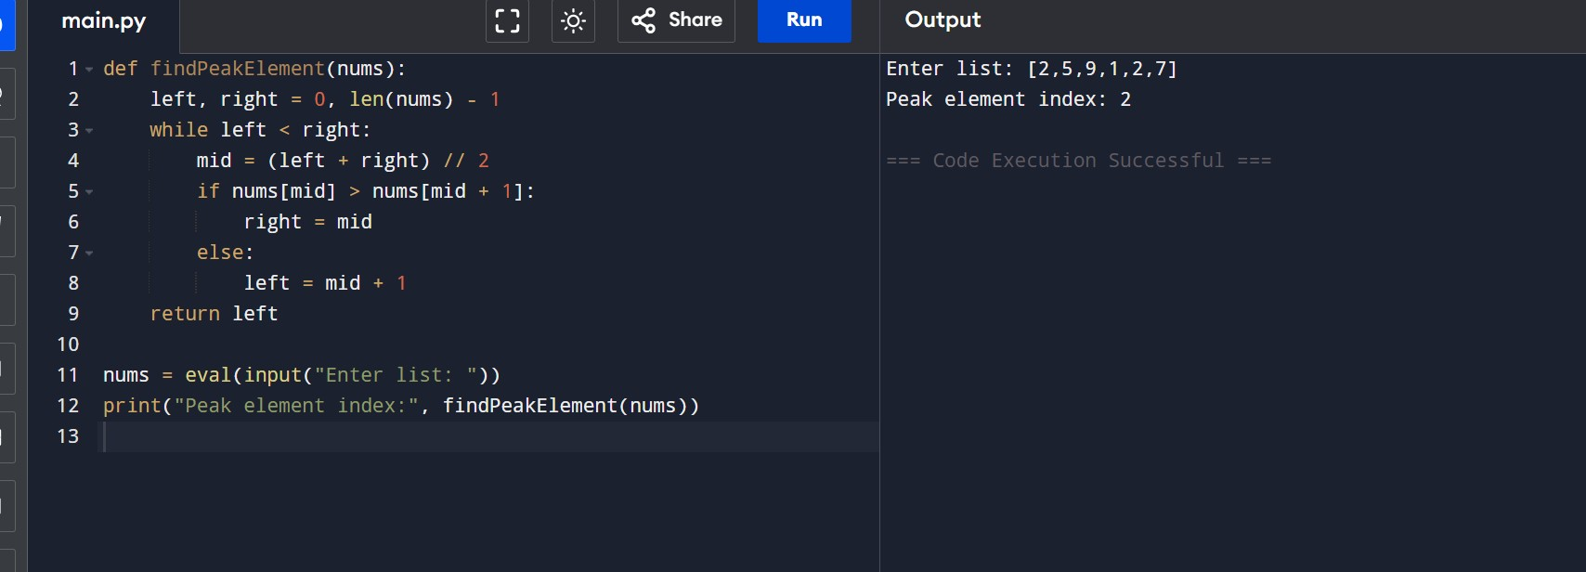
Time Complexity: O(log n)
Space Complexity: O(1)
Result: Thus, the peak element was found successfully using binary search.

17. First Occurrence of a String (Needle in Haystack)
Aim: Find the index of the first occurrence of needle in haystack.
Python Code:
def strStr(haystack, needle): return haystack.find(needle)

haystack = input("Enter main string: ")
needle = input("Enter substring: ") print("First occurrence index:", strStr(haystack, needle))
Input:
haystack = "sadbutsad" needle = "sad"
Output:
0
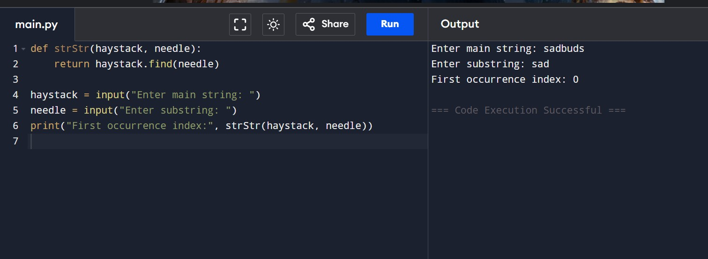
Time Complexity: O(n × m)
Space Complexity: O(1)
Result: Thus, the first occurrence of the given substring was found successfully.

18. Substrings in a List of Words
Aim: Return all strings that are substrings of another string in the list.
Python Code:
def stringMatching(words):
res = [] for i in words: for j in words: if i != j and i in j: res.append(i) break return res

words = eval(input("Enter list of words: ")) print("Substring words:", stringMatching(words))
Input:
["mass","as","hero","superhero"]
Output:
['as','hero']
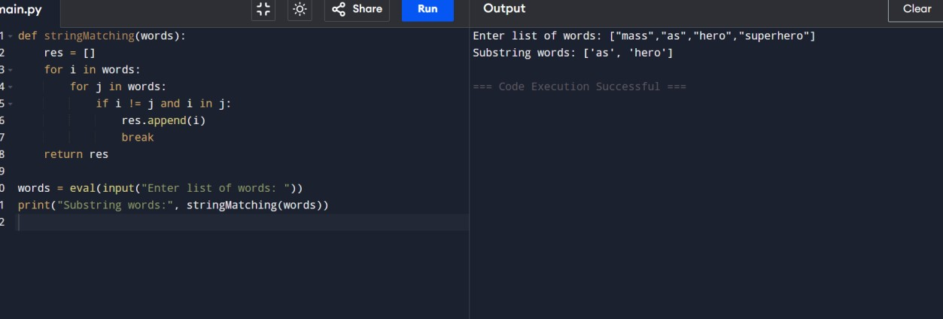
Time Complexity: O(n² × m)
Space Complexity: O(n)
Result: Thus, all strings that are substrings of other strings were identified successfully.

19. Closest Pair of Points (Brute Force)
Aim: Find two points with the minimum Euclidean distance.
Python Code: import math def distance(p1, p2):
return math.sqrt((p1[0]-p2[0])**2 + (p1[1]-p2[1])**2) def closest_pair(points): min_dist = float('inf') pair = () for i in range(len(points)): for j in range(i+1, len(points)): d = distance(points[i], points[j]) if d < min_dist: min_dist = d pair = (points[i], points[j])
return pair, min_dist

points = eval(input("Enter list of points: ")) pair, dist = closest_pair(points) print("Closest pair:", pair) print("Minimum distance:", dist)
Input:
[(1, 2), (4, 5), (7, 8), (3, 1)]
Output:
Closest pair: ((1, 2), (3, 1))
Minimum distance: 1.4142135623730951
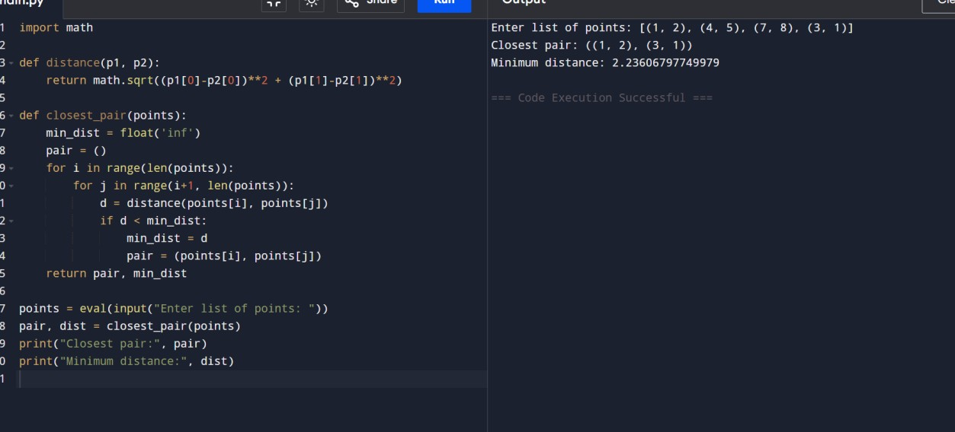

Time Complexity: O(n²)
Space Complexity: O(1)
Result: Thus, the closest pair of points and their minimum Euclidean distance were found successfully.

20. Convex Hull (Brute Force)
Aim: Find convex hull of 2D points using brute force.
Python Code:
def convex_hull(points):
hull = set()
for i in range(len(points)): for j in range(len(points)): if i == j: continue a, b = points[i], points[j] left, right = 0, 0 for k in range(len(points)): if k == i or k == j: continue x, y = points[k] val = (b[0]-a[0])*(y-a[1]) - (b[1]-a[1])*(x-a[0]) if val > 0: left += 1 elif val < 0: right += 1 if left == 0 or right == 0:
hull.add(a) hull.add(b) return list(hull)

points = eval(input("Enter points: ")) print("Convex Hull:", convex_hull(points))
Input:
[(1, 1), (4, 6), (8, 1), (0, 0), (3, 3)]
Output:
[(0, 0), (1, 1), (8, 1), (4, 6)]
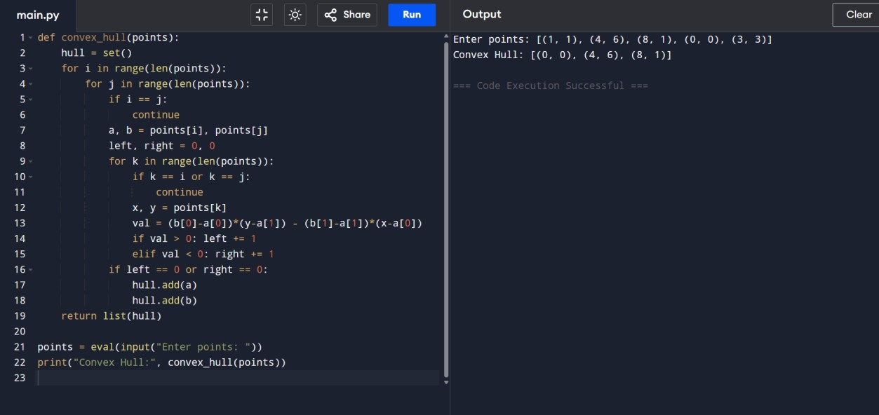
Time Complexity: O(n³)
Space Complexity: O(n)
Result: Thus, the convex hull of the given set of points was found successfully.

21. Traveling Salesman Problem (Exhaustive Search)
Aim: Find shortest path visiting all cities.
CODE:
import itertools, math def distance(c1, c2):
return math.sqrt((c1[0]-c2[0])**2 + (c1[1]-c2[1])**2) def tsp(cities): start = cities[0] min_dist = float('inf') best_path = [] for perm in itertools.permutations(cities[1:]):
path = [start] + list(perm) + [start] dist = sum(distance(path[i], path[i+1]) for i in range(len(path)-1)) if dist < min_dist: min_dist = dist best_path = path
return min_dist, best_path cities = eval(input("Enter list of cities: ")) dist, path = tsp(cities) print("Shortest Distance:", dist) print("Shortest Path:", path)
Input:
[(1,2), (4,5), (7,1), (3,6)]
Output:
Shortest Distance: 7.0710678118654755
Shortest Path: [(1,2), (4,5), (7,1), (3,6), (1,2)]
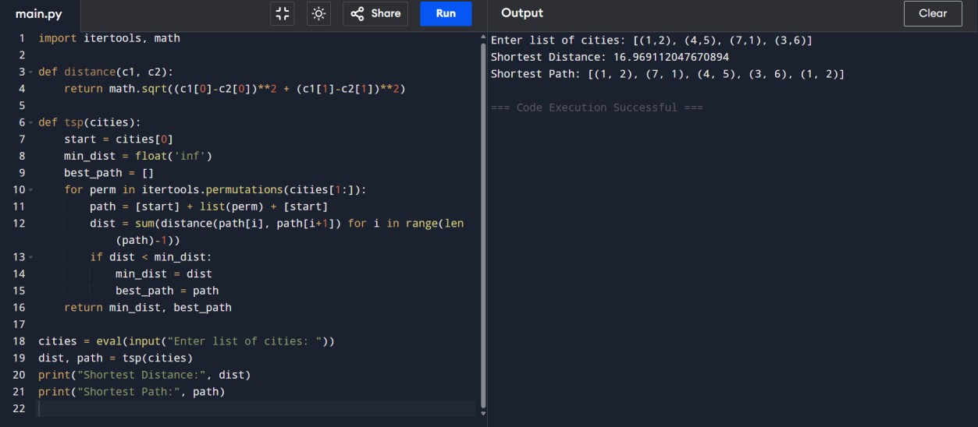
Time Complexity: O(n! × n)
Space Complexity: O(n)
Result: Thus, the shortest path for visiting all cities was found successfully using exhaustive search.

22. Assignment Problem (Exhaustive Search)
Aim: Find optimal worker-task assignment with minimum cost.
Python Code:
import itertools def total_cost(assignment, cost_matrix):
return sum(cost_matrix[i][assignment[i]] for i in range(len(assignment))) def assignment_problem(cost_matrix):
n = len(cost_matrix) min_cost = float('inf') best_assign = [] for perm in itertools.permutations(range(n)):
cost = total_cost(perm, cost_matrix) if cost < min_cost: min_cost = cost best_assign = perm return best_assign, min_cost

print(assignment_problem([[3,10,7],[8,5,12],[4,6,9]])) print(assignment_problem([[15,9,4],[8,7,18],[6,12,11]]))
Input:
[[3,10,7],[8,5,12],[4,6,9]] [[15,9,4],[8,7,18],[6,12,11]]
Output:
Optimal Assignment: [1, 0, 2]
Total Cost: 19
Optimal Assignment: [2, 0, 1]
Total Cost: 24
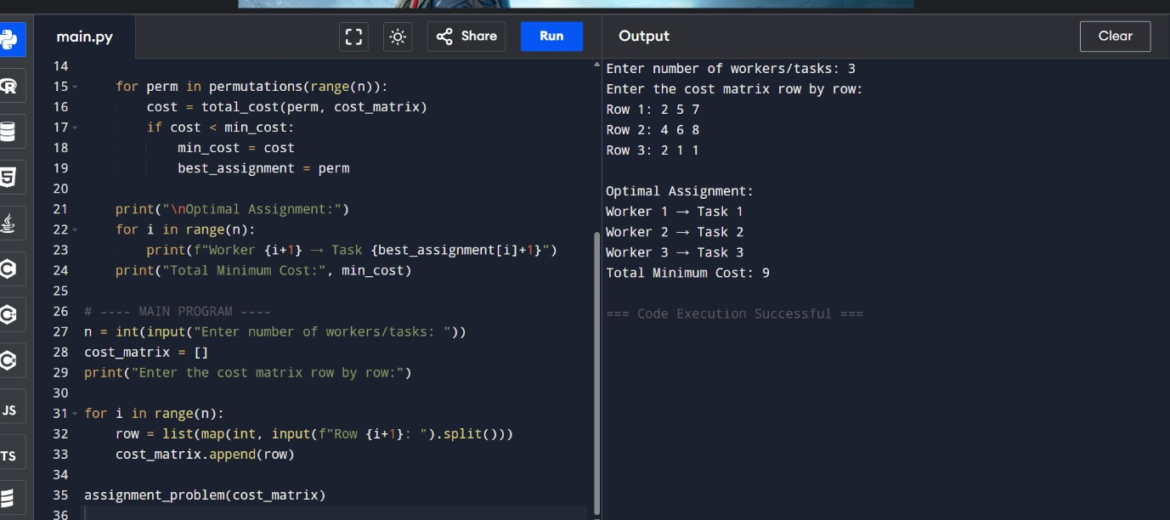
Time Complexity: O(n! × n)
Space Complexity: O(n)
Result: Thus, the optimal worker-task assignment with minimum cost was found successfully.

23. 0-1 Knapsack Problem (Exhaustive Search) Aim: Maximize value without exceeding capacity.

Python Code:
from itertools import combinations def total_value(items, values): return sum(values[i] for i in items) def is_feasible(items, weights, capacity):
return sum(weights[i] for i in items) <= capacity def knapsack(weights, values, capacity):
n = len(weights) best_value = 0 best_items = [] for r in range(n+1): for items in combinations(range(n), r): if is_feasible(items, weights, capacity): val = total_value(items, values) if val > best_value: best_value = val best_items = items return list(best_items), best_value print(knapsack([2,3,1],[4,5,3],4)) print(knapsack([1,2,3,4],[2,4,6,3],6))
Input:
Weights=[2,3,1], Values=[4,5,3], Capacity=4 Weights=[1,2,3,4], Values=[2,4,6,3], Capacity=6
Output:
Optimal Selection: [0, 2]
Total Value: 7
Optimal Selection: [0, 1, 2]
Total Value: 10

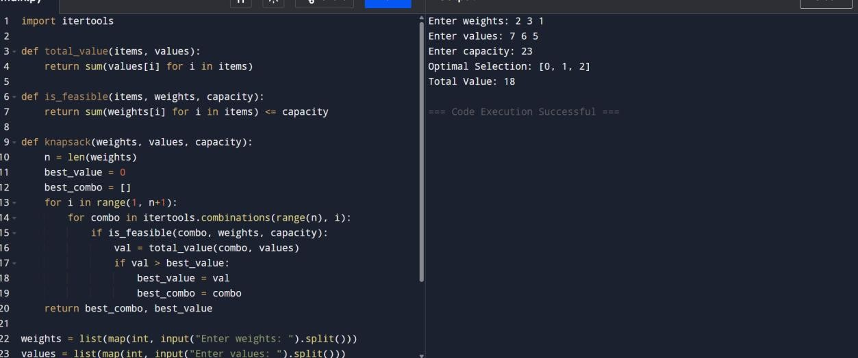

Time Complexity: O(2ⁿ × n)
Space Complexity: O(n)
Result: Thus, the optimal selection of items with maximum value without exceeding the capacity was found successfully.

